ANNEXURE-I
Information Regarding Mandatory Disclosure of Math Department
Nam of Programme : Nil
Approved Intake : N.A
Fees Charged (Per annum) in Rs. : N.A
Pass Percentage during last five years : As per record of Academic Section
Teacher student Ratio : N.A.
No. of Faculty Members : 09 (Regular) + 03 (on Contract)
Cadre Number
Professor 02
Associate Professor 07
Assistant Professor 03(on Contract)
Faculty Profile :
Qualification Number of Faculty
Ph.D : 08
Post Graduate : 04
Experience of Faculty :
Number of Faculty with
Less than five years : 03
5-10 years : Nil
More than 10 years : 09
Details of individual faculty members :
Name, photograph, Date of Birth, Qualifications,
Professional Experience, Research Interests,
Name of the faculty Member: Dr. Sukhjit Singh Dhaliwal
Qualification : M.Sc., M.Phil., Ph.D
Date of Birth : 8.11.1960
Experience : 22 years of Teaching and Research
Research Interest: Complex Analysis/ Numerical Analysis
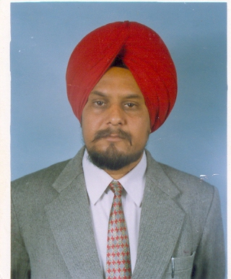
Name of the faculty Member: Dr. Mandeep Singh
Qualification : Ph.D
Date of Birth : 27.7.64
Experience : 18 years
Research Interest: Linear Algebra /Matrix Analysis
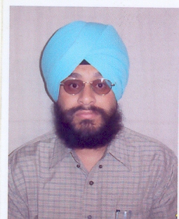

Name of the faculty Member: Dr. Vinod Mishra
Qualification : M.Sc., Ph.D
Date of Birth : 15.03.1968
Experience : 18 years
Research Interest : History of Mathematics /Wavelet Analysis
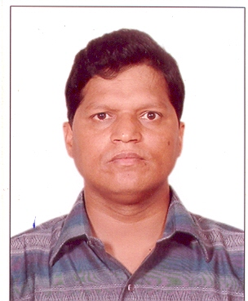
Name of the faculty Member: Dr. Sushma Gupta
Qualification : M.Sc., M.Phil.,Ph.D
Date of Birth : 20.10.1961
Experience : 18 years
Research Interest : Complex Analysis

Name of the faculty Member: Mr.R.K.Goyal
Qualification : M.Sc., M.Phil.
Date of Birth : 12.09.1957
Experience : 20 years
Research Interest : -
Name of the faculty Member: Dr. R.K.Guha
Qualification : M.Sc., Ph.D
Date of Birth : 27.01.1962
Experience : 15 years
Research Interest : Operation Research /Numerical Analysis /Financial Mathematics
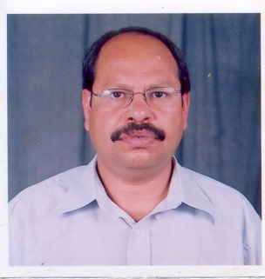

Name of the faculty Member: Dr. R.K.Mishra
Qualification : M.Sc., Ph.D
Date of Birth : 05.10.1971
Experience : 16 years
Research Interest : Cosmology/Operation Research /Numerical Analysis
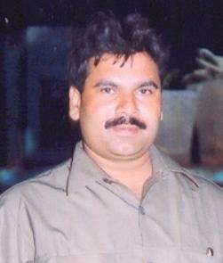
Name of the faculty Member: Dr. J.R. Sharma
Qualification : M.Sc., Ph.D
Date of Birth : 10.05.67
Experience : 14years
Research Interest : Theory of Relativity /Numerical Analysis
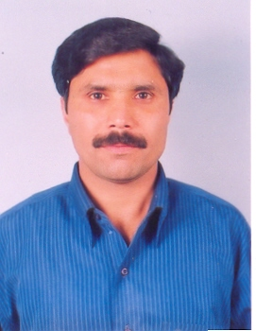

Name of the faculty Member: Dr. V.K.Kukreja
Qualification : M.Sc., Ph.D
Date of Birth : 12.10.1967
Experience : 14 years
Research Interest : Mathematical Modeling

Industrial Consultancy, Research and Development (during five years):
Amount of Industrial Consultancy earned (in lakhs of Rs) : -
No. of sponsored research projects completed : 01
No. of Patents produced : -
No. of sponsored research projects in progress : 01
No. of Papers published in International/National Journals : 70
No. of Papers presented in International conferences /Seminars : 05
No. of Papers presented in National conferences /Seminars : 21
No. of International Conferences conducted : -
No. of National Conferences conducted : 01
No. of Training Program Short term courses conducted : 02
Placement Record for Previous year : -
No. of Companies visited the campus : -
Name and Detail of the Companies who visited the campus
along with No. of Students placed : -
No. of Students placed through campus requirement : -
Maximum salary drawn (in Rs.) : -
Average salary drawn (in Rs.) : -
Budget Allocation for the Programme (in Rs.) : -
Recurring :
Non Recurring :
New initiative and future vision, if any :
Note: Suppression and /or misrepresentation of information would attract

