MECHANICAL ENGINEERING DEPARTMENT

- Faculty profile, adequacy & competency of faculty :

S.  No. | Name | Photograph | Date of  Birth | Date of Joining  (Institute) | Professional  Qualification | Nature of Employment | Research Interests
 | Dr. V. Sahni, Prof. | 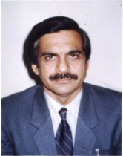 | 28.11.54 | 16.10.1992 | Ph.D | Regular | Thermal Engineering
 | Sh. Amrik Singh, ASP | 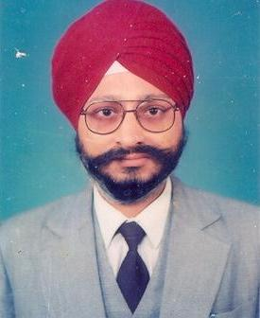 | 22.06.61 | 10.09.1999 | M.E. | Regular | Production & Industrial System Engineering
 | Dr. H.S.Bains, ASP |  | 11.05.63 | 15.06.1999 | Ph.D | Regular  (On Deputation to PTU.) | Composites
 | Sh. K.P.Singh, ASP | 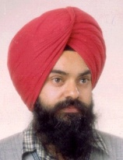 | 11.01.70 | 08.03.1999 | M.Tech. | Regular | System Dynamics, CAD/CAM
 | Sh. M.A. Akhtar, ASP | 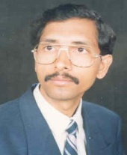 | 08-07-65 | 14.09.1992 | M.Tech. | Regular | Non conventional energy
6. | Dr. P.K.Singh, Prof. | 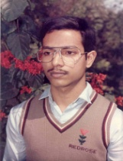 | 15.05.67 | 27.09.1994 | Ph.D. | Regular | Tolerance Design, Design for manufacture & assembly, Non traditional optimization, Modeling & Simulation
 | Dr. Pardeep Gupta, Prof. | 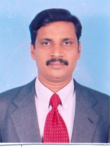 | 24.11.67 | 20.02.1991 | Ph.D. | Regular | Industrial & production Engineering
 | Dr. Rajesh Kumar, ASP | 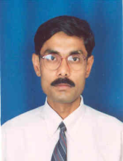 | 01.01.67 | 26.09.1994 | Ph.D. | Regular | Vibrations, Condition monitoring,Opto-mechatronics,
 | Sh. Manoj Kumar, ASP | 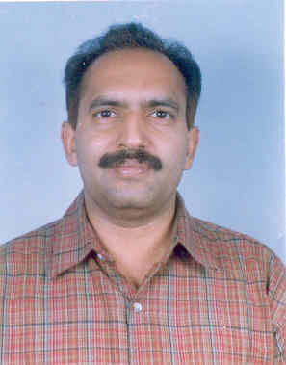 | 13.12.64 | 21.02.1993 | M.E. | Regular | Industrial Engg., Mechanical Measurements
 | Sh. S.C.Verma, ASP | 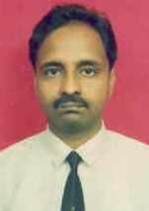 | 01.05.65 | 30.08.1993 | M.E. | Regular | Refrigeration & Air conditioning
 | Dr. Kulwant Singh, ASP |  | 18.11.61 | 18.10.1991 | Ph. D. | Regular | Welding Engineering  Production Engineering
 | Dr. Jatinder Madan, ASP | 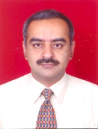 | 04.01.70 | 11.05.1993 | Ph. D | Regular | CAD/CAM, DFM, Design Automation, PLM
 | Dr.Vikas Rastogi, ASP. | 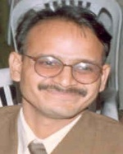 | 30.06.72 | 22.08.1995 | Ph. D | Regular | Modeling Simulation, System Dynamics
 | Dr. R. K. Saxena, ASP. | 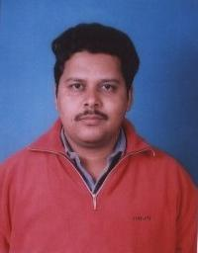 | 04.07.73 | 11.06.1996 | Ph.D. | Regular | FEM, Metal Forming, High Velocity Impact Plasticity, Vibrations
 | Sh.Anil Singla, ASP. | 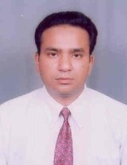 | 16.12.70 | 13.06.1995 | M.E. | Regular | Robotics, Mechatronics, System Dynamics and Control
 | Sh. J.S.Gill, A.P | 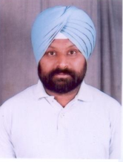 | 27.01.72 | 10.09.1996 | ME | Regular | Production Engineering
 | Dr. A.S.Shahi, ASP. | 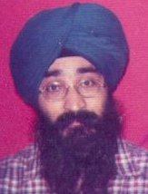 | 23.01.69 | 20.06.1996 | Ph.D | Regular | Welding Metallurgy, Material Joining
18. | Dr.Shankar Singh, ASP | 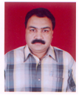 | 23.07.1964 | 10.07.2007 | Ph.D | Regular | Manufacturing Process, Non Traditional Machining, Processing of Metal Matrix Composites (MMCs)
19. | Sh.R.K.Yadav  ASP. | 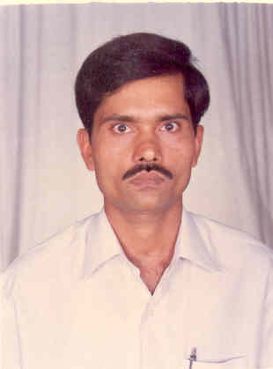 | 26.12.66 | 23.06.1995 | M.Tech. | Regular | Fluid mechanics, Thermal Engineering
20. | Sh. Arvind Jayant, ASP | 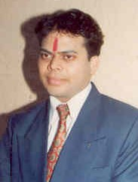 | 19.03.73 | 01.08.1996 | M.Tech. | Regular | Industrial Engineering
21. | Dr. H.K.Kansal, ASP. | 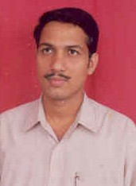 | 01.01.72 | 26.08.1997 | Ph.D. | Regular  (On Lien) | EDM, Production technology
22. | Dr. Jagtar Singh, A.P | 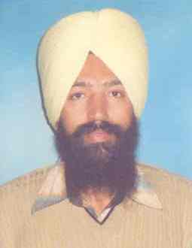 | 02.05.69 | 25.10.1997 | Ph.D | Regular | Industrial Engineering, Optimization Techniques, Bio Energy, Friction Stir Welding
23. | Sh. Indraj Singh  A.P. | 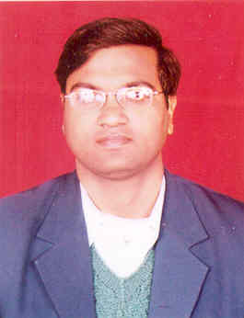 | 10.07.74 | 29.08.1997 | M.E. | Regular | Energy auditor ( Power Plant, Sugar industry etc), Alternative fuel and IC engine.
24. | Sh.Rakesh Kumar, A.P. | 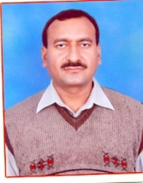 | 06.04.1965 | 22.08.1997 | M.E. | Regular | Production  Technology
25 | Sh. Surinder Kumar  A.P. | 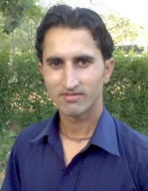 | 13.01.1981 | 28.09.2006 | B.E | Regular | 1. Manufacturing Technology  2. Welding  Technology
26. | Sh. Harish Kumar Arya , A.P. | 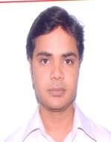 | 15.08.1982 | 08.10.2006 | M.Tech | Regular | 1. Welding  Technology,  2. Thermal Modeling & Simulation
27. | Sh Sunil Kumar,  A.P. | 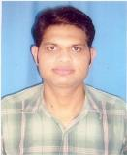 | 26.10.1979 | 16.10.2006 | M.E. | Regular | CAD/CAM
28. | Sh. Mohd. Majid,  A.P. | 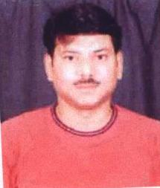 | 12.09.1973 | 01.08.2007 | M.Tech | Regular | Welding technology
29. | Sh. Manpreet Singh,  A.P. | 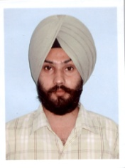 | 12.01.1979 | 07.08.2007 | B.E | Regular | Manufacturing
30. | Sh. Sumit Kumar,  A.P. | 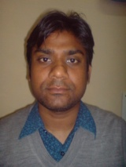 | 12.03.1982 | 17.08.2007 | B.E | Regular | Refrigeration & Air Condition
31. | Sh. Vivek Kumar,  A.P. |  | 05.07.1977 | 28.10.2007 | M.Tech. | Regular | Manufacturing Systems Engineering

- Student profile according to the programs of study, Region, Gender in last five years:

Region  Course | Other States | Punjab State | No. of Students(Gender Wise) | Total
 |  |  |  | Male | Female
Certificate | 256 | 648 | Certificate | 901 | 03
Diploma | 145 | 569 | Diploma | 706 | 08
Degree | 231 | 239 | Degree | 466 | 04
M.Tech | 38 | 32 | M.Tech | 67 | 03

- Changes made in the courses or programmes during past five years and the contribution of faculty to these changes:
Study schemes and course contents are revised so as to keep the curriculum updated and in tune with the recent trends in academics/industry. Workshops are conducted to carry out this process and faculty of SLIET does brain storming along with experts from industry and reputed academic institutes. Faculty plays an active role in this process.

- Trend in the success rate and drop rate of students during the last five years: (On institute basis)
CERTIFICATE
Passing year | 2005 | 2006 | 2007 | 2008 | 2009
% of Passes | 75.12 | 52.77 | 67.91 | 77.34 | 76.38

DIPLOMA
Passing year | 2005 | 2006 | 2007 | 2008 | 2009
% of Passes | 93.93 | 96.34 | 92.56 | 95.55 | 89.01

DEGREE
Passing year | 2005 | 2006 | 2007 | 2008 | 2009
% of Passes | 75.17 | 77.49 | 70.64 | 78.42 | 71.94

POST GRADUATE
Batch | 2005 | 2006 | 2007 | 2008 | 2009
% of Passes | 100 | 100 | 93.75 | 90.47 | *

*Thesis work going on.

- Learning resources of the department like library, computers, laboratories and other such resources:
Laboratories (No. of Labs-14):
- Advanced Welding Lab
- Non destructive Testing Lab
- Metrology Lab.
- CAD/CAM Lab.
- Simulation Lab.
- Mechatronics Lab.
- SOM Lab.
- TOM Lab.
- Thermal Engineering Lab.
- Hydraulics Lab.
- Refrigeration and Air-conditioning Lab.
- Auto-Farm Lab.
- Innovation Centre
- Industrial Engineering

No. of computers in all labs: 125

No. of books in library: 154

Thesis in M.E.: 40

Projects of B.tech: 200

- Enhancement of the learning resources during the past five years:
Department has two lecture/seminar halls which are equipped with multimedia facilities. Teachers are encouraged to plan their course in advance and prepare soft copies of learning material. Central as well as departmental Libraries are updated every year so that latest books are available to the students. Following equipments /software have been purchased during last five years:
- Four stroke four cylinder petrol Engine
- Symbol shakti software
- Gas analyzer
- Single cylinder four stroke diesel engine test Rig
- Hand Tachometer
- Stir Casting Equipment with accessories
- Cut model
- Four Stroke Four cylinder of Diesel Engine
- Four stroke Single Cylinder of Petrol Engine
- Air Conditioning Trainer
- Domestic Refrigerator Rig
- Dell server
- Master CAM software
- CATIA V5 software
- ARENA software
- SPC software
- Micro hardness Tester
- Image Analysis Software
- Electrolytic Polishing Machine
- Universal Testing Machine(Digital)
- Thermal Spray Gun
- Electronic Weighing Balance(Digital)
- Variable Compression Ratio Multi Fuel Engine Test
- Electronic Weighing Balance (Digital)
- Image Acquisition System
- Lab View
- Vibration Analyzer
- Digital Storage oscilloscope
- Data Acquisition System
- Ansys Software
- Digital Viscometer
- Semi Automatic Bio Diesel Plant

Purchase orders of following equipments have been placed and delivery waited:
- Fuel Consumption meter
- Demonstration tractor differential
- Mechanical heat pump
- Refrigeration fault simulator
- Mini cold storage trainer
- Stereo Zoom microscope
- Impact testing machine
- Automatic Polishing machine
- Hand dynamometer and tri axial accelerometer with data acquisition system
- Muscle Monitoring system through EMG
- Low Force Vibration Model Shaker/ Exciter along with amplifier
- Function Generator
- Miniature Accelerometer Kit
- CNC Simulation Software

- Modern teaching methods in practice other than the lecture method:
Multimedia presentations, internet, quiz, seminars and group discussions are integral part of curriculum.
- Participation of teachers in academic and personal counseling of students:
Well established counseling system is in place for counseling of students. Department level coordinators help Chief counselor to disseminate counseling among students through individual course counselors. Regular counseling sessions are conducted by Course counselors to inculcate moral values in students apart from technical education.

- Details of faculty development programmes and teachers who benefited during the past five years:
The department has organized 08 Nos. short term training programmes for the development of the faculty. Faculty members from the department have attended 92 Nos. short term courses organized by SLIET Longowal and other engineering institutes.

- Participation of teachers in academic activities other than teaching & research:
Teachers are permitted to attend short term courses/workshops at Institutes of national repute anywhere in India. Short term courses and workshops are conducted a SLIET campus also to keep the faculty up dated. Teachers are involved in examination related activities like paper setting, examination duty, student evaluation etc.

- Collaboration with the other departments and institutions at the national and international levels and their outcome during past five years: NIL.

- If research is a significant activity, the thrust areas of the department:
Following are thrust areas:
(a) CAD/CAM
(b) System Dynamics and Control.
(c) Non conventional Machining
(d) Welding

- The details of ongoing projects& projects completed during the last five years:

TITLE OF THE PROJECT | INVESIGATORS | SPONSORING AGENCY | DURATION | AMOUNT IN LACS | STATUS
Automated design of die from part product model | Dr. Jatinder Madan, Dr. Sukhwinder Singh | AICTE | 3 years | 9.00 | In progress

- “Programmes by Research” offered by the university in mechanical engineering department:
Programmes offered: 1. PhD. In the followings
- Welding
- Vibration Analysis
- Metal Cutting/ Scheduling
- CAD/CAM
- Non-conventional Machining
- Ergonomics
- Industrial engineering
- Availability/Reliability
- System Dynamics
- I.C. engines
2. M.Tech in the following specializations-
a. Manufacturing Systems Engineering
b. Welding technology

- Publications of the faculty, for the past five years. Details regarding citation index and impact factor analysis.
No. of papers published in international journals : 56
No. of papers published in national journals : 20
No. of papers presented in international conferences/ seminars : 104
No. of papers presented in national conferences/ seminars : 163

- Participation of the department in the extension activities of the university:
Department is involved in vocational courses under CDC (Country Development Centre) and Scheme for PWD (Persons with disabilities).

- Method of continuous student assessment:
Students are assessed continuously throughout the semester by:
(a) Minor tests (three) at regular intervals.
(b) Quiz.
(c) Lab viva and practical skill tests.
(d) Tutorials and assignments.

- Placement record of the past students and the contribution of department in student placements:
No. of graduate students placed: 215 (in last five years).There is a separate Training & Placement department in the institute. The department organizes industry institute meet every year to enhance placement of students. The department profile is prepared every year to apprise industry about the department’s activities.

- Significant achievements of the department or faculty or students during the past five years:
- Two teams (‘JUNKYARD WARRIORS’ and ‘SLIETIAN SPARKZ’) that registered for BAJA SAE (Society of Automotive Engineers) INDIA 2009 for a 3 Day BAJA SAE INDIA Student Competition that was held at NATRAX Facility of NATRIP, Pithampur near Indore from 30th to 1st Feb 2009, got 1st prize.
- Department has organized 07 Nos. national conferences.
- Department has organized 08 No. of Training Programmes / Short Term Courses
- The department has already acquired one patent and has applied for the second patent

- Participation of the department in COSIT/COHSSIT/SAP/CAS/DASA/DRS/FIST etc.:
Financial assistance by department of science & technology (SERC division), ministry of science & technology, government of India has sanctioned to department of Mechanical Engineering, SLIET, Longowal in the year 2003 on FIST programme. The total amount sanctioned for the development of infrastructure and labs in the department was 6.5 lacs.
The total tenure of the project was five years which was successfully completed in the year 2009. The total of 17, 52,867/- including the interest was utilized for the development of infrastructure in labs.

- Plan of action of the department for the next five years:

- Setting up of Advance Centre of Manufacturing
- Learning Resources for certificate & Diploma
- Setting up of an industry sponsored chair in thrust area
- Development & promotion of industrial consultancy
- Development of institute workshop as Production/Training centre
- Energy Auditing centre
- Modernization of centre of innovation

